**Investigating Wheels**

**Aim**

To investigate the effect of a wheel and axle when lifting a load.

**Hypothesis**

*The _____________ a handle is, the __________ turns it will take to lift the load.*

more / less

longer / shorter

**Equipment**

|  |  |
| --- | --- |
| * 500mL beaker or tin can * 3 paper clips * length of stiff wire or skewer | * string * 50g mass * sticky tape |

**Method**

1. Set up the equipment as shown below.
2. Tape the two paper clips to hold the wire axle in position.
3. Try to lift the 50g mass by twisting the wire around using your thumb and index finger. Count how many turns of the wire it takes to lift the load to the top of the beaker.
4. Now, remove the paperclips and remove the wire. Bend the end without the masses to form a handle as shown below.
5. Reassemble the equipment and now try to lift the masses by turning the handle.
6. Now, reassemble the equipment again, making the handle on the end of the wire larger. Try to lift the masses by turning the handle.

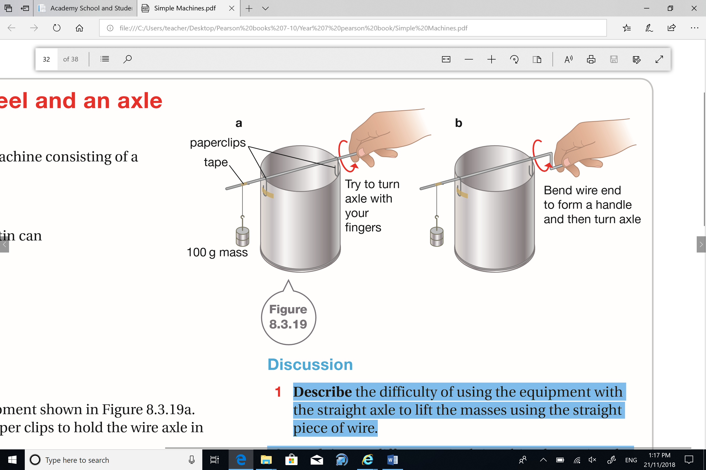

**Variables**

|  |  |  |
| --- | --- | --- |
| *Independent Variable  (what are you changing?)* | *Dependent Variable  (what are you measuring?)* | *Controlled Variables (what are you keeping the same?)* |
|  |  |  |

**Results**

|  |  |  |  |  |
| --- | --- | --- | --- | --- |
| **Length of handle (cm)** | **Number of Turns** | | | |
| **Trial 1** | **Trial 2** | **Trial 3** | **Average** |
| 0 |  |  |  |  |
|  |  |  |  |  |
|  |  |  |  |  |
|  |  |  |  |  |

**Graph**

|  |  |  |  |  |  |  |  |  |  |  |  |
| --- | --- | --- | --- | --- | --- | --- | --- | --- | --- | --- | --- |
|  |  |  |  |  |  |  |  |  |  |  |  |
|  |  |  |  |  |  |  |  |  |  |  |  |
|  |  |  |  |  |  |  |  |  |  |  |  |
|  |  |  |  |  |  |  |  |  |  |  |  |
|  |  |  |  |  |  |  |  |  |  |  |  |
|  |  |  |  |  |  |  |  |  |  |  |  |
|  |  |  |  |  |  |  |  |  |  |  |  |
|  |  |  |  |  |  |  |  |  |  |  |  |
|  |  |  |  |  |  |  |  |  |  |  |  |
|  |  |  |  |  |  |  |  |  |  |  |  |
|  |  |  |  |  |  |  |  |  |  |  |  |
|  |  |  |  |  |  |  |  |  |  |  |  |

**Discussion**

Answer the following questions in your book or device:

1. Did your results support your hypothesis? Explain your answer.
2. Describe the difficulty of using the equipment with the straight axle to lift the masses using the straight piece of wire.
3. Explain any differences in doing this when using the bent handle.
4. Propose a reason this change makes the task easier.
5. This handle is acting as a lever. Identify why turning the handle provides the force advantage needed to lift the mass.
6. Identify three places you’ve seen systems similar to this being used to provide a force advantage.
7. How could you change the design of this experiment to make your results more accurate?